Knightlow C of E Primary School
‘Learn from me’
Reception Learning Newsletter
September 2026
Dear Parents,
Welcome to Reception Class! The children are settling in well and getting used to our busy routine. The children have started planning their learning on the theme ‘Autumn Harvest’ and will be exploring and investigating the changes and treasures of this season, using related stories and songs to inspire learning activities. We will also be involved in our whole school project ‘Taking Care’ and activities related to ‘Nursery Rhymes’
Mrs Amos-Simpson
AUTUMN TERM-First Half
Literacy
Your child will be practicing and developing speaking and listening skills through circle games and sharing news. Our role play and story focus will be inspired by the author Nick Butterworth and his stories about Percy the Park Keeper. The children will be developing their knowledge of letters and sounds through daily phonics sessions. They will also be working towards recognising all letters by shape, sound and name and writing letters clearly. They will have lots of opportunities to share and listen to stories in a range of ways too.
Maths
Through practical activities and games there will be daily opportunities for counting, comparing and ordering. We will be working on recognising and writing number symbols 1-20. Through practical activities both child-initiated and adult-led, children will be encouraged to develop problem solving skills, develop awareness of number patterns and recognise the properties of shapes around us.
Physical Development
During our PE sessions and other activities, we will be developing our balance, spatial awareness and fitness. We will also be using the large apparatus. Your child will also have lots of opportunities to develop fine motor and gross motor skills through ‘Dough Disco’ and ‘Squiggle whilst you Wriggle’ sessions.
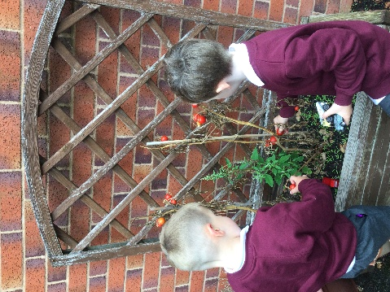


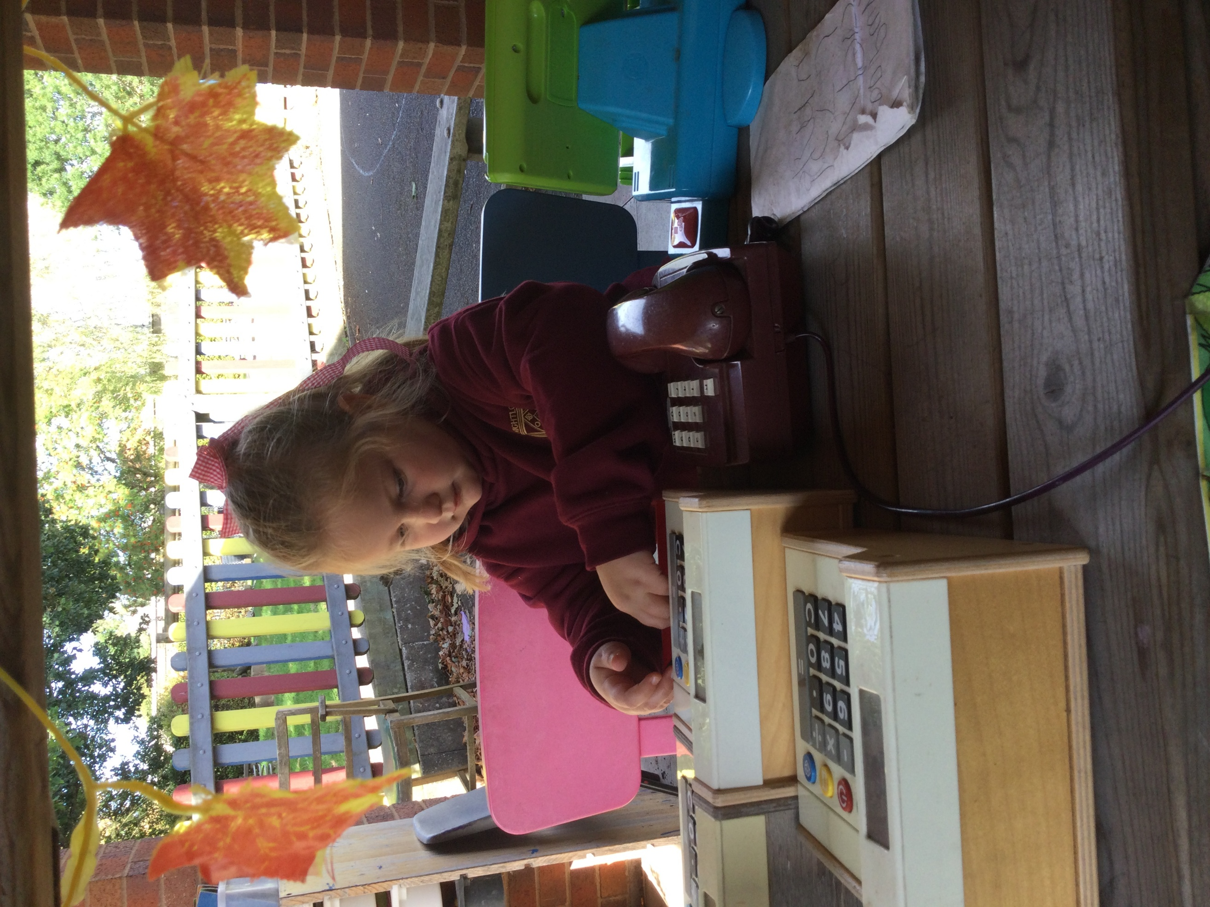
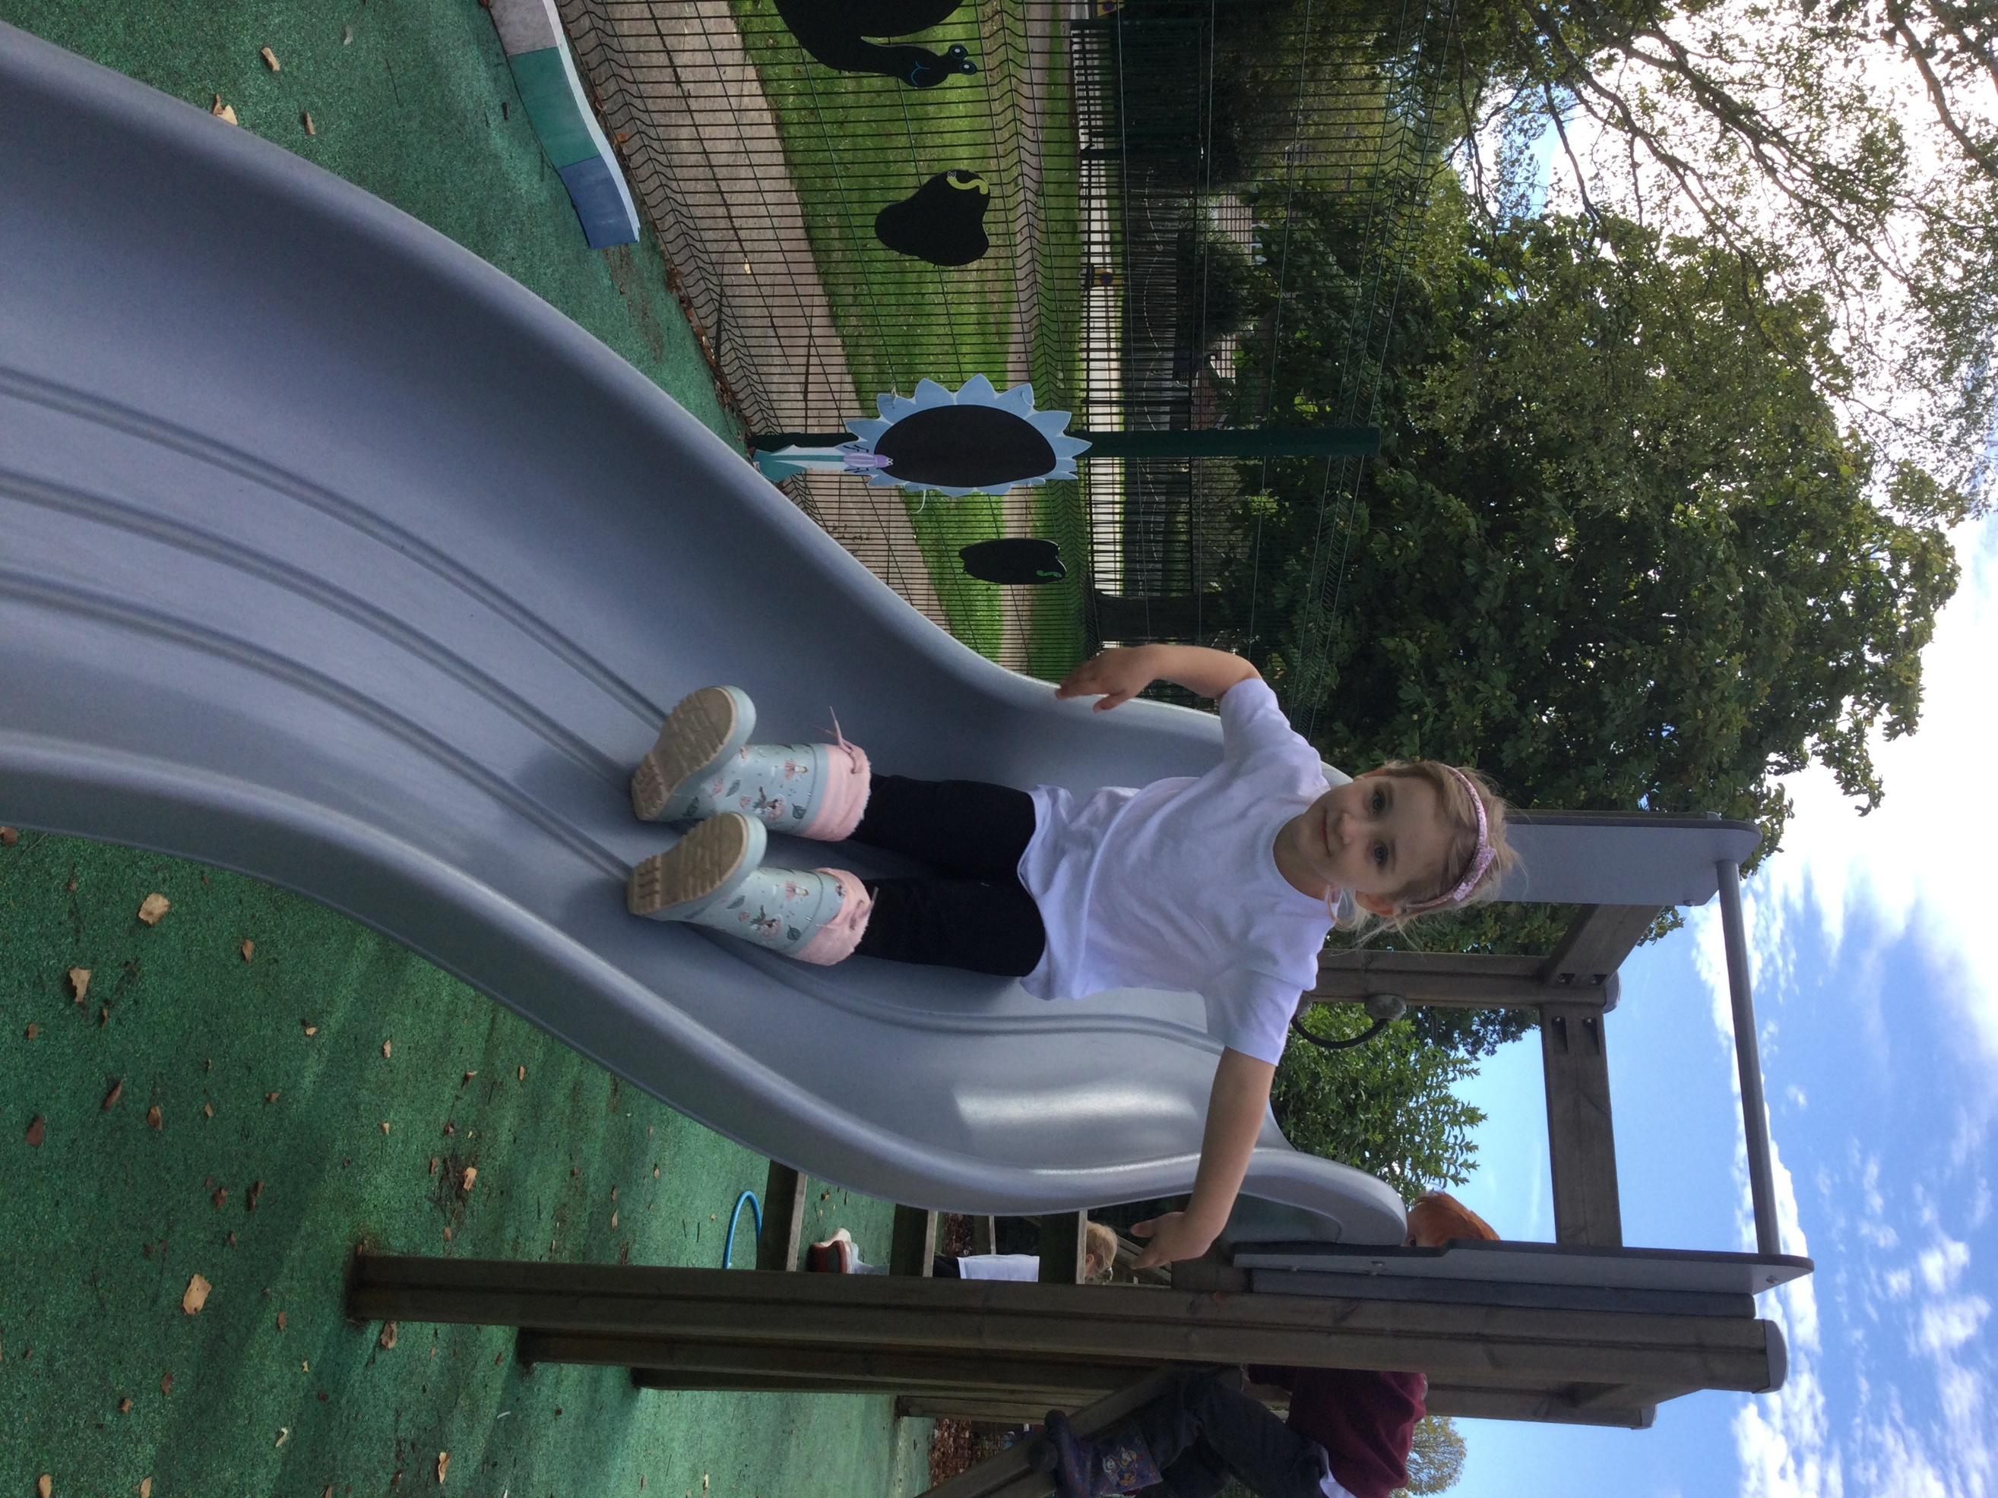

AUTUMN TERM LEARNING – FIRST HALF
Understanding the World
We will be looking at seasonal changes of autumn and celebrating Harvest and will be harvesting and tasting our own vegetables grown in our garden, learning about life as a farmer and enjoying a tractor visit. We will also be learning about how other people celebrate Harvest. We will be learning how to make playdough, cook our own bread and follow other recipes. We will also be using our Forest school site regularly.
R.E.
We will learn about special books including the Christian Bible, learning from our persona dolls as they teach us about God and the Creation story in the Bible, we will be learning about Harvest Festivals as well as learning about the Jewish Harvest Festival of Sukkot.
Expressive and Creative Arts
Lots of out Art and design activities will be linked to our Autumn theme and there will be a whole school focus on poetry. The children will be learning a wide range of songs and rhymes. They will take part in weekly music sessions which will include using instruments, recognising sound patterns, rhythm, tone and volume.
Special Events and Activities
Macmillan Coffee Morning Friday 25th September
Harvest Festival at All Saint’s Church Wednesday 14th October
Inset Day Friday 16th October
Parent Evenings Tuesday 21st and Wednesday 22nd October
Reception Welcome Service Wednesday 21st October at 9.15am
Half Term Monday 26th October
Term Begins Tuesday 4th November

We always appreciate any help you can give in supporting your child’s learning here are some of the ways you can help:
- Asking your child about their day and sharing news about the things they have done.
- Listening to your child read or sharing books together.
- Asking questions about the stories you share, encouraging children to look for clues in the pictures, asking them what’s happening in the story, asking them to predict what might happen next, look for tricky non-decodable words.
- Practicing writing their names and other familiar words using a cursive script.
- Practicing counting how many altogether ?
- Encouraging children to look for numbers eg birthday cards, front doors, price tags, car registration plates
- Providing plenty of outdoor and indoor play, and early nights!

Helping At Home
We always appreciate any help you can give in supporting your child’s learning here are some of the ways you can help:
- Asking your child about their day and sharing news about the things they have done.
- Listening to your child read or sharing books together every day.
- Asking questions about the stories you share, encouraging children to look for clues in the pictures, asking them what’s happening in the story, asking them to predict what might happen next, look for tricky non-decodable words.

- Practicing writing their names and other familiar words.
- Practicing counting how many altogether?
- Encouraging children to look for numbers eg birthday cards, front doors, price tags, car registration plates
- Providing plenty of outdoor and indoor play, and early nights!

